Purpose

Servicers of conventional MPF Traditional Conventional loans must submit the Workout Worksheet (Form SG354) to the MPF Provider when recommending a Temporary Loan Payment Modification Plan. **The completed form must be accompanied by the Traditional Temporary Loan Payment Modification Appendix and all supporting documentation as noted on the SG354 Form Instructions.**

The intent of a loan modification is to eliminate the arrearage and provide the Borrower, who is in default or facing imminent default, with a monthly loan obligation that is affordable and sustainable. A temporary loan payment modification plan (Modification Plan) may be an appropriate loss mitigation option only after all other loss mitigation options have been exhausted or determined to be ineffective given the Borrower’s circumstances.

Preparation

* **When** - The Servicer must complete the Workout Worksheet (Form SG354) and **Traditional Temporary Loan Payment Modification Appendix** when recommending a Temporary Loan Payment Modification workout option for a Borrower.
* **Who** -This forms must be completed by an employee of the Servicer who has responsibilities that would cause such individual to be knowledgeable of the facts and processes needed to complete the form and has authority to certify to the truthfulness and accuracy of the information on the form.
* **Attachments** - The completed Workout Worksheet (Form SG354) and **Traditional Temporary Loan Payment Modification Appendix** must be accompanied with the following documentation:

1. Workout Worksheet (Form SG354)
2. Borrower Hardship Certification (Form SG402)
3. Insurer Approval Letter, if applicable
4. Pay Stubs
5. Bank Statements
6. Tax Returns
7. Credit Report
8. 4506-T and Tax Transcripts from IRS*
9. Any other documentation to support the Borrower’s financial information

* Effective February 1, 2021, PFIs must ensure a properly completed IRS Form 4506-C, instead of a Form 4506-T, is in every mortgage loan file delivered into the program. (See Exhibit T-X for an example of a completed 4506-C).

Submission

* **How** – The official form must be completed and any supporting documentation must submitted through eMAQCS®plus at [https://eMAQCS.covius.com.](https://emaqcs.covius.com/)
* **To Whom** – The completed form must be submitted to the MPF Provider. The Servicer should retain a copy of the completed form and supporting documentation for their own records.

Temporary Loan Payment Modification Prior Approvals

The Servicer must obtain approval, prior to offering a Temporary Loan Payment Modification to a Borrower.

**For temporary loan modifications, the eligibility requirements in MPF Traditional Servicing Guide Chapter 9 must be met.** In addition to ensuring the Modification Plan meets all requirements in this chapter, the Servicer must obtain approval from the applicable primary and/or supplemental mortgage insurer prior to the Borrower’s execution of the modification agreement. In addition, the Servicer must submit the required documentation (See Section 9.2.6) to the MPF Provider and receive approval prior to sending the modification agreement to the Borrower for signature. Servicer must allow for a minimum of 5 Business days processing of such requests.

Temporary Loan Payment Modification Plan Eligibility Requirements

|  |  |
| --- | --- |
| **Mortgage and Borrower Eligibility Requirements** | |
| **Delinquency** | In default or in imminent danger of default because the Borrower’s income has involuntarily declined and/or expenses have unexpectedly increased. |
| **Lien Position** | * Must be a 1st Lien * Must be a Conventional Mortgage |
| **Other Loss Mitigation Options** | * All other Loss Mitigation options have been exhausted or determined to be ineffective given the borrower’s circumstance.   1. Repayment Plan   2. Forbearance Plan   3. COVID-19 Payment Deferral Plan, if eligible |
| **Hardship** | * The Mortgage is in Default or facing imminent default because the borrower’s income has involuntarily declined and/or expenses have unexpectedly increased |
| **Primary Residence** | * The Mortgaged Property serves as the Primary Residence for, and is occupied by, at least one of the borrowers that signed the promissory note included in the Mortgage. The Servicer is required to complete a property inspection to validate the occupancy status of the Mortgaged Property within ninety (90) days of the Modification Plan request |
| **Property Condemned** | * The Mortgaged Property has not been condemned and is not in such poor physical condition that it is not habitable |
| **Previous Modifications** | * The Mortgage was not previously modified for loss mitigation purposes (if previously modified, requires escalation to MPF Bank) |
| **EPD Loans** | * The Servicer must obtain its MPF Bank’s approval prior to pursuing a Modification Plan for any EPD Mortgage Loan |

|  |  |
| --- | --- |
| **Pre Mod Front End HTI** | * The borrower’s Pre-Mod HTI must exceed 31% HTI |
| **General Items and Special Restrictions** | |
| **Escrow Spread** | * Escrow to be spread over a 36 month period |
| **Trail Period Plan** | * 3 month trial plan required |
| **Post Mod UPB** | * Post Modified UPB cannot be over the original UPB |
| **Cash Contribution** | * If the Borrower is able to make a cash contribution, it must be applied pursuant to the Note and Applicable Law. |
| **Post-Mod UPB ≥ 50% DTI** | * If the borrower’s total debt ratio exceeds 50% after the Mortgage Loan is modified, the borrower must complete credit counseling from a HUD Approved Agency |
| **Temporary 36 Month Relief** | * This modification will give the borrower temporary relief from their current payment for a total of 36 months including their trial payments. Example 3 month trial and 33 month   Temporary reduced payments. |

Underwriting the Temporary Loan Payment Modification Plan

The Servicer is required to analyze the Modification Plan request from a Borrower to determine whether a modification would feasibly permit the Borrower to cure or avoid a Delinquency. The goal of a modification is to provide a payment, which under the Borrower’s current circumstances, is affordable and sustainable. Therefore, the **Borrower’s monthly housing expense ratio should not exceed 31%,** including any subordinate financing payments. In situations where a Borrower does not meet the requirements for a Modification Plan, the Servicer should deny the Borrower’s modification request. However, if the Servicer feels special consideration is warranted, the Servicer may submit a proposed alternative to the MPF Provider for review via eMAQCSplus, clearly indicating that the proposal is outside the requirements of the Modification Plan and specifying terms the Servicer proposes.

Where the Borrower’s current housing expense ratio exceeds 31%, the Mortgage Loan is in default or facing imminent default, and a Modification Plan appears feasible to cure or avoid a Delinquency, the Servicer will need to consider several modification terms in order to achieve a target housing ratio of 31% under the Modification Plan, cumulatively if necessary, in the exact following order:

1. If the Borrower is able to make a cash contribution, it must be applied pursuant to the Note and Applicable Law.
2. Capitalize remaining delinquent interest only (costs, fees or escrow items should not be capitalized) by adding it to the unpaid Principal Balance. However, if this capitalization would result in a Principal Balance exceeding the original Principal Balance funded by the MPF Bank, all the delinquent interest should be written off.
3. Reduce the Principal and Interest payments for up to thirty-six (36) months, based on an amortization schedule up to 40 years (480 months) from the original Note date. At the end of the thirty-six (36) month term, the original Principal and Interest payments stated in the Note are reinstated, unless another Modification Plan is approved. The full Principal Balance of the Mortgage Loan, including any capitalized interest, will be due and payable on the original loan maturity date. Please note that the scheduled payments do not fully amortize the modified Mortgage Loan and will result in a balloon payment being due at maturity.
4. Reduce for up to thirty-six (36) months the interest rate in 0.125% increments below the original Note Rate, to a floor rate of 3.00%.

Temporary Loan Payment Modification Plan Terms and Document Execution

**Prior to implementing a Modification Plan, the Servicer must complete, but not sign, the following documents:**

• Loan Workout Plan (Form SG400), which implements an initial three (3) month trial period;

• Temporary Loan Payment Modification Agreement (Form SG401); Workout Worksheet (Form SG354); and

• All required disclosures.

The Servicer must submit all necessary documentation to the MPF Provider for review and receive approval prior to sending any documentation to the Borrower for signature.

Once the Loan Workout Plan (Form SG400) and the Temporary Loan Modification Agreement (Form SG401) are executed by the Borrower, and the Loan Workout Plan (Form SG400) is executed by the Servicer, the Borrower will be given a trial period of three (3) months, during which their new modified payments must be made on time as described in the Loan Workout Plan (Form SG400). The Servicer must hold the modified trial period payments in suspense status as “unapplied funds” in the T&I Custodial Account, until all three (3) payments are made as agreed, at which point the Servicer must apply the three (3) payments to the Mortgage Loan in accordance with the terms of the Temporary Loan Payment Modification Agreement.

If the Borrower fails to make any of the trial period payments on time or fails to meet any other requirements of the trial period as stipulated in the Loan Workout Plan (Form SG400), the Modification Plan will be immediately terminated, which includes cancellation of any proposed capitalization or write-off of delinquent interest and a return to the original Note Rate and terms, P&I payments, interest rate, and amortization schedule.

If the Borrower meets all the requirements of the trial period as stipulated in the Loan Workout Plan (Form SG400), the Servicer can modify the loan payments for the next thirty-three (33) months.

Steps for PFI/Servicer to Complete the Temporary Loan Payment Modification Appendix

**Step 1** - Create a new Temporary Loan Payment Modification Appendix form in eMAQCSplus. On the main screen roll your cursor over **Forms** in the black ribbon at the top of the page and select **Add/View Forms.**

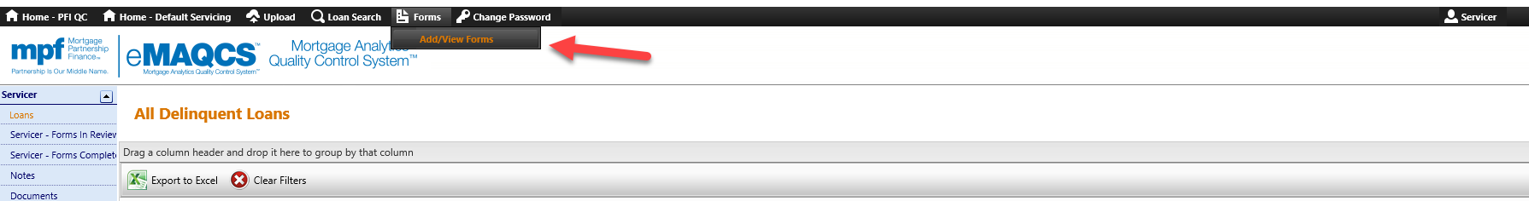

**Step 2** - On the screen that populates next enter the MPF loan number into the box and click the **Submit button**.

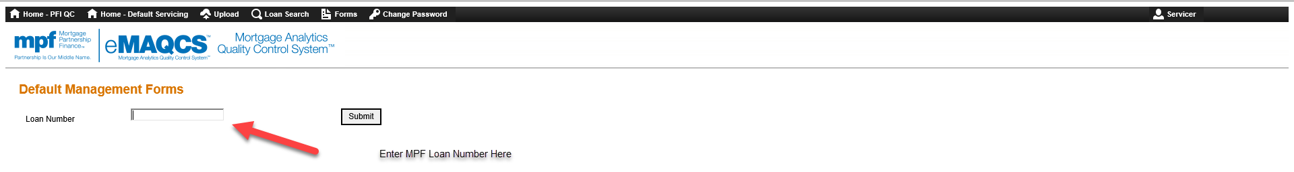

**Step 3** - On the screen that populates next click the drop-down arrow in the box titled Select Form. Select the **Traditional Temp Modification Appendix Modification Appendix** form by clicking on it and then click **Create**.

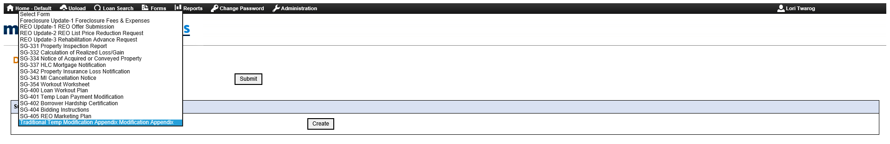

The **Traditional Temporary Loan Payment Modification Appendix** form will populate. Select **View**. Note that there are three tabs. A Formtab, a Document tab and an Instructions tab. The **Instructions** tab includes a link to the Workout Worksheet (SG354 Form) and provides direction on when to complete the form and what information and documents need to be included with the form submission. 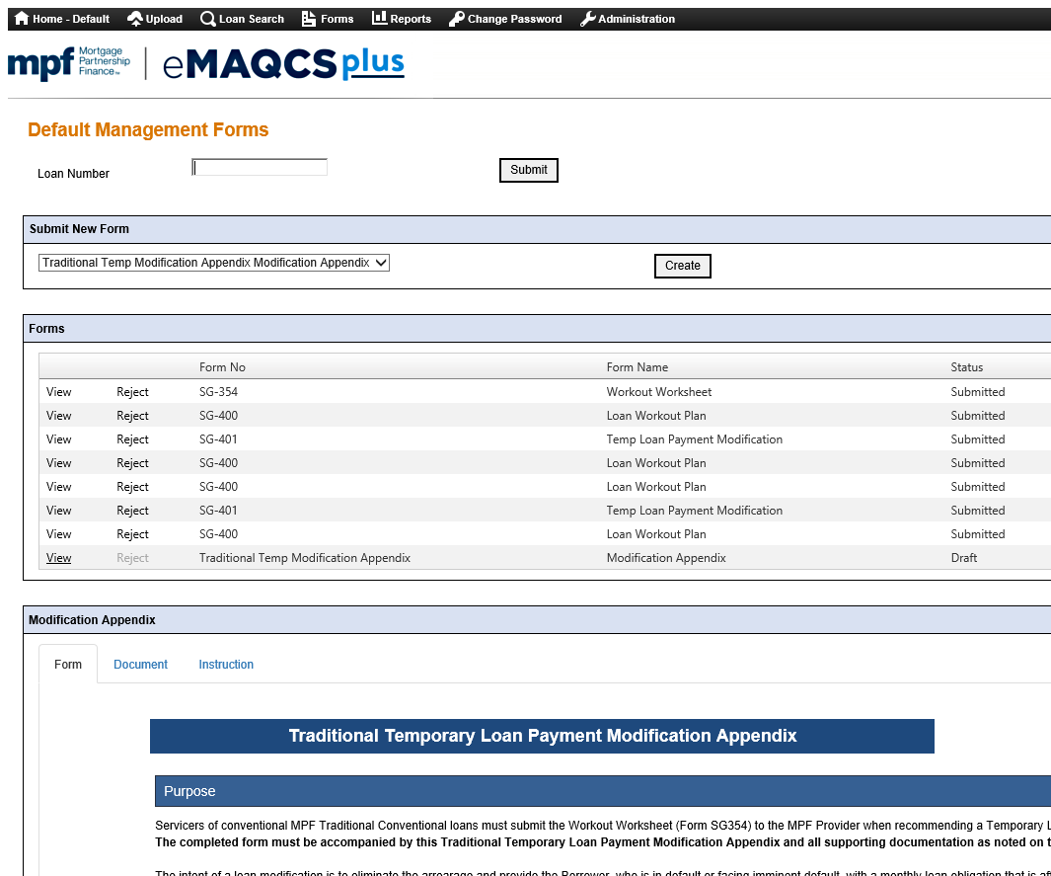

**Step 4** – Select the **Form** tab and complete the all of the required fields in the Form tab including the radio buttons under the Temporary Loan Payment Modification Plan Eligibility Checklist, Original Loan Information, Current Loan Information, Modified Loan Information and Underwriting sections of the Traditional Temporary Loan Payment Modification Appendix form.

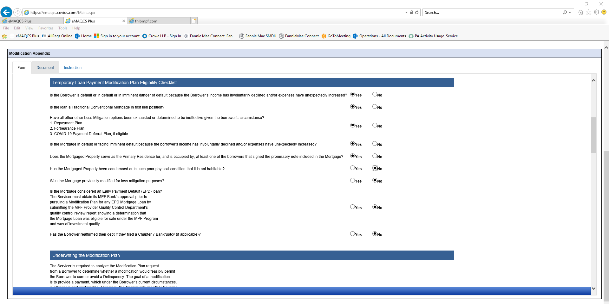

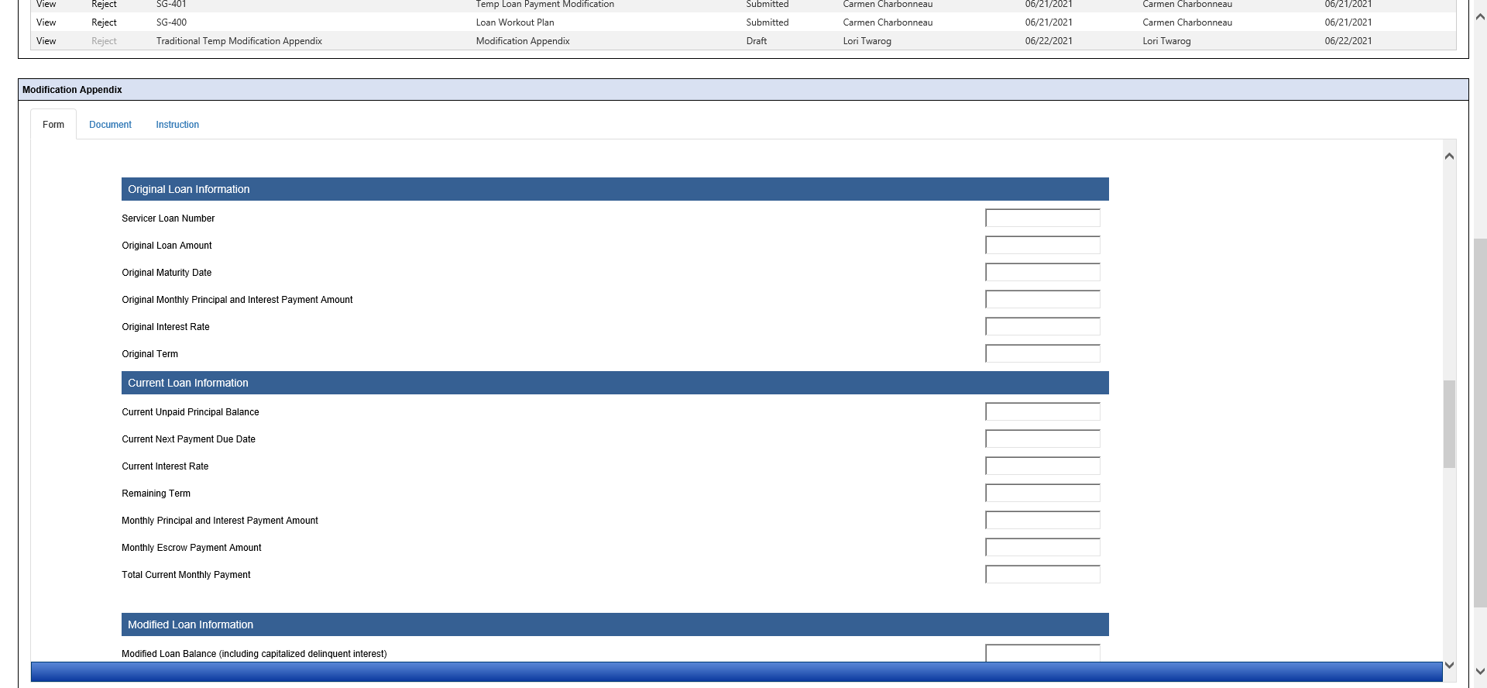

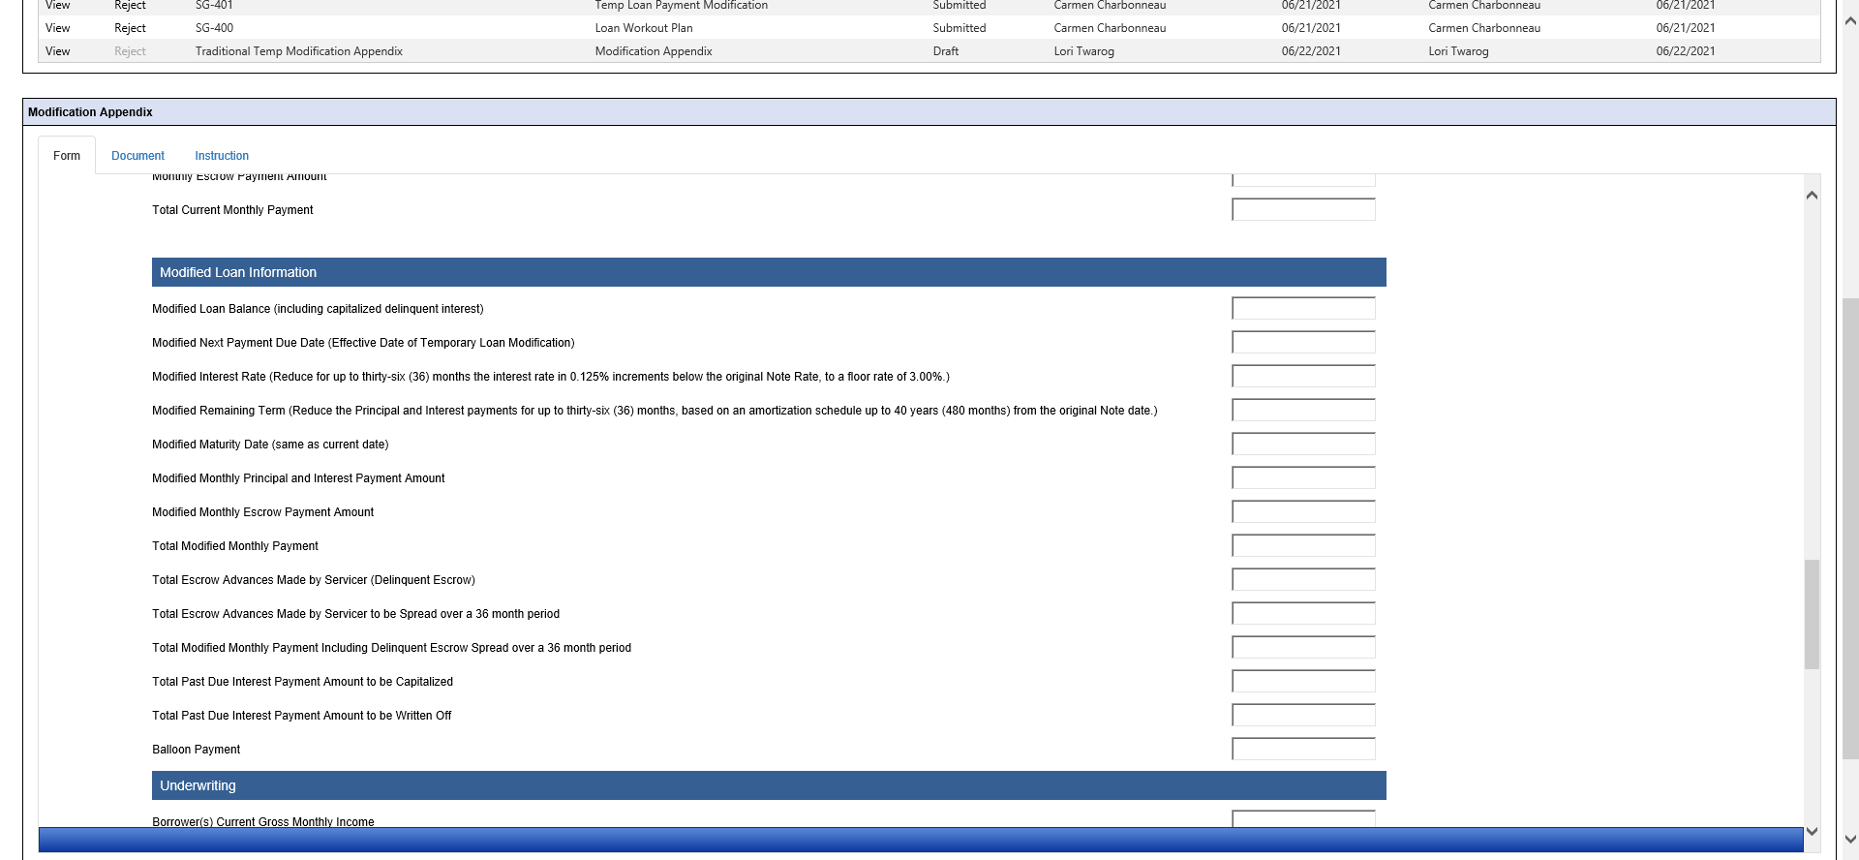

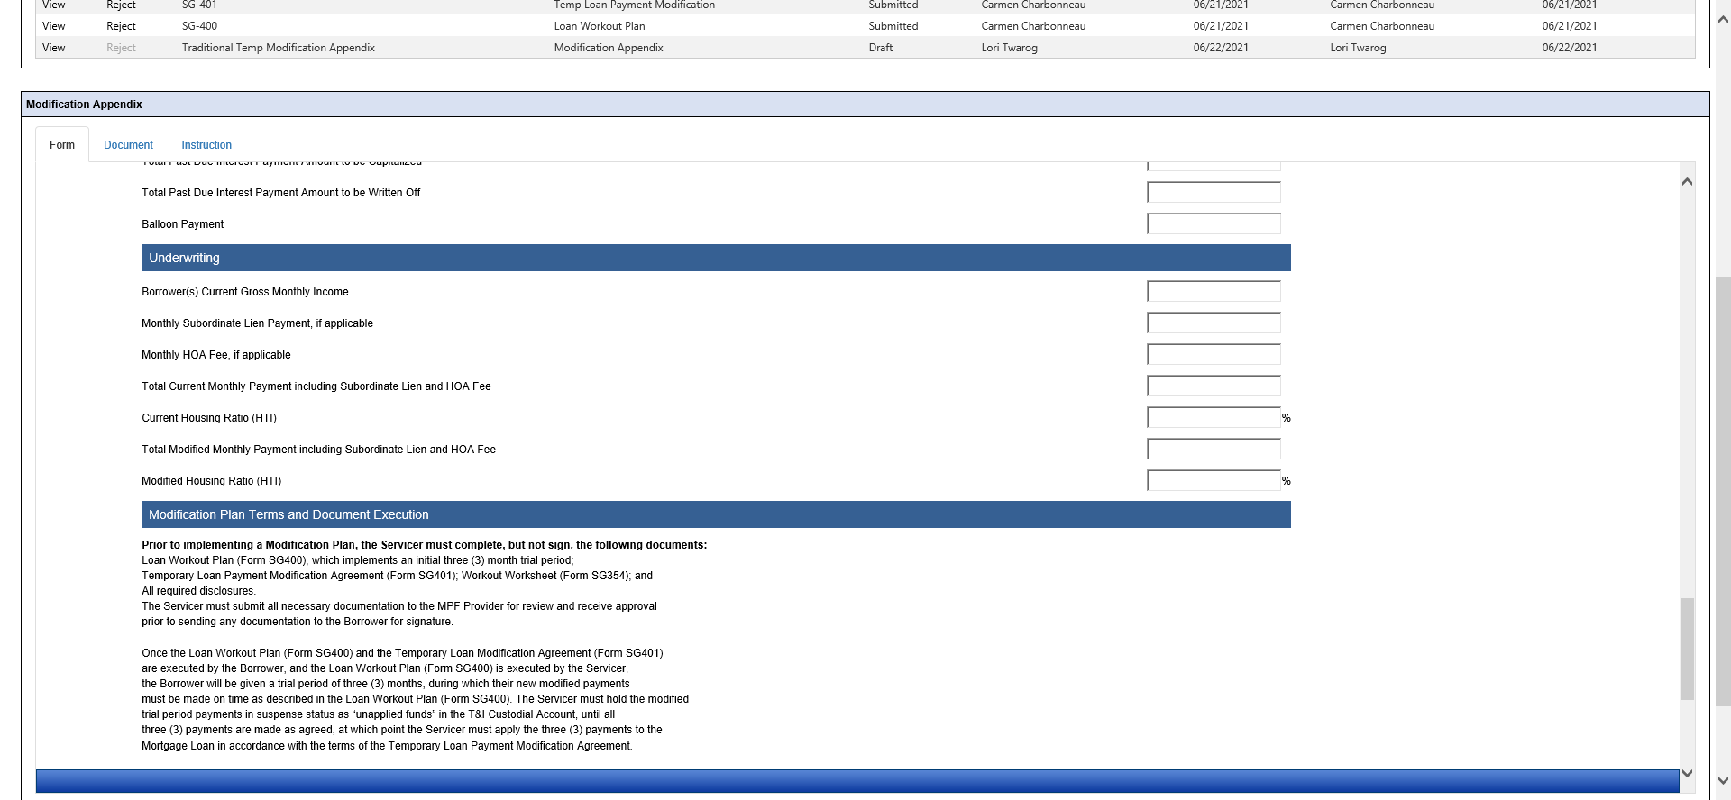

**Step 5** – Select the button at the bottom of the form to **Save as Draft**.

It is best practice to click the Save as Draft button prior to submitting your form. If any of the required information is missing will get the below error message.

If this error message populates please review the form for fields highlighted in red, complete those fields with the appropriate information and click the Save as Draft. If all of the required fields are populated successfully you will receive a **Success! Record has been saved** message.

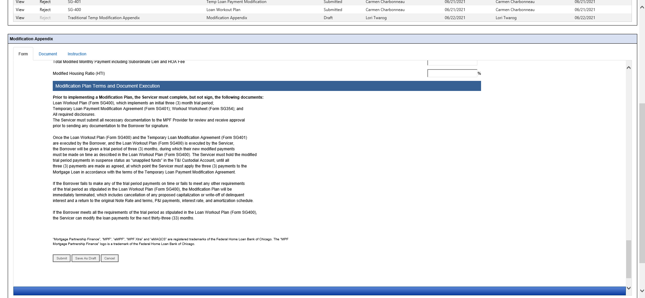



**Step 6** – Attach any supporting documentation prior to submitting the form. Select the **Document** tab and upload the supporting documents. You can drag and drop the documents in the appropriate Documents buckets that are displayed.

The document bucket icon will turn green and a row with the name of the document will populate to indicate that you have successfully saved the document to the Document tab.

**You can upload multiple documents into one of the green or blue and white icons. The only naming convention requirement for documents being uploaded document tab is that apostrophes and commas cannot be used.**

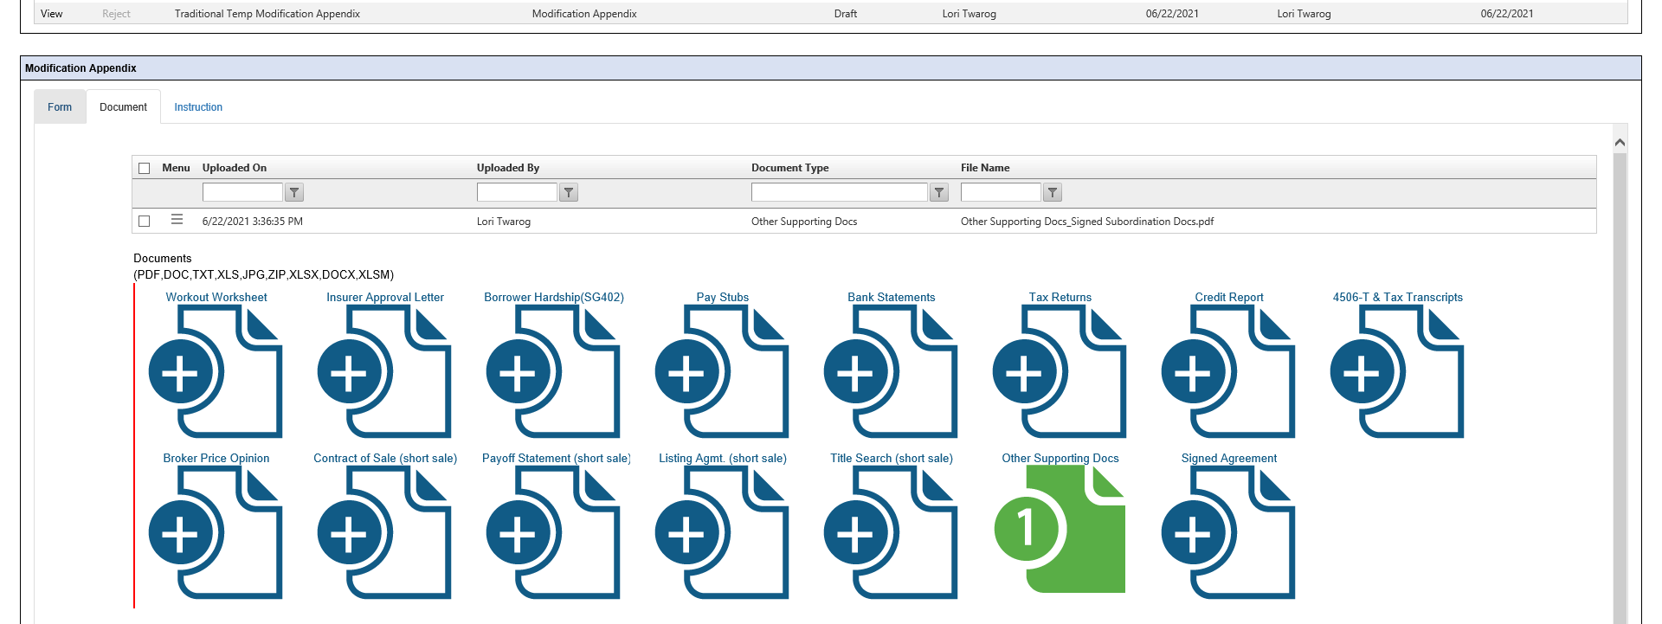

**Step 7** – How to submit the Form successfully

Once you are ready to submit your form, return to the **Form** tab and scroll down to the bottom of the form. Click **Submit**.

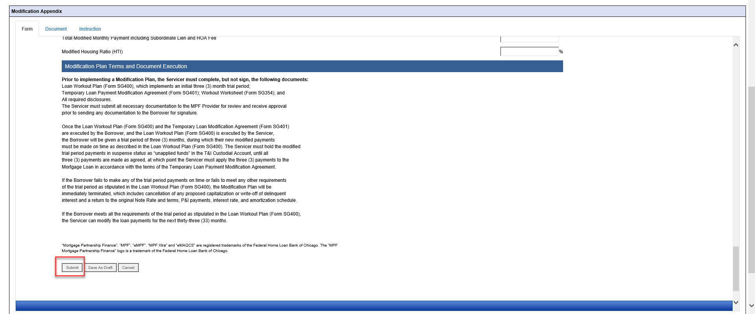

If the form was not successfully submitted you will get a message that says **Validation Error!!** If this error message populates please review the form for fields highlighted in red and complete those fields with the appropriate information.



If successfully submitted, a message of **Success!! Record Has Been Saved** populates.

To double check the submission status of your form refresh your browser. A status of **Draft** as indicates that the form is in Draft and has not yet been successfully submitted. A status **Submitted** indicates that the form has been successfully submitted.

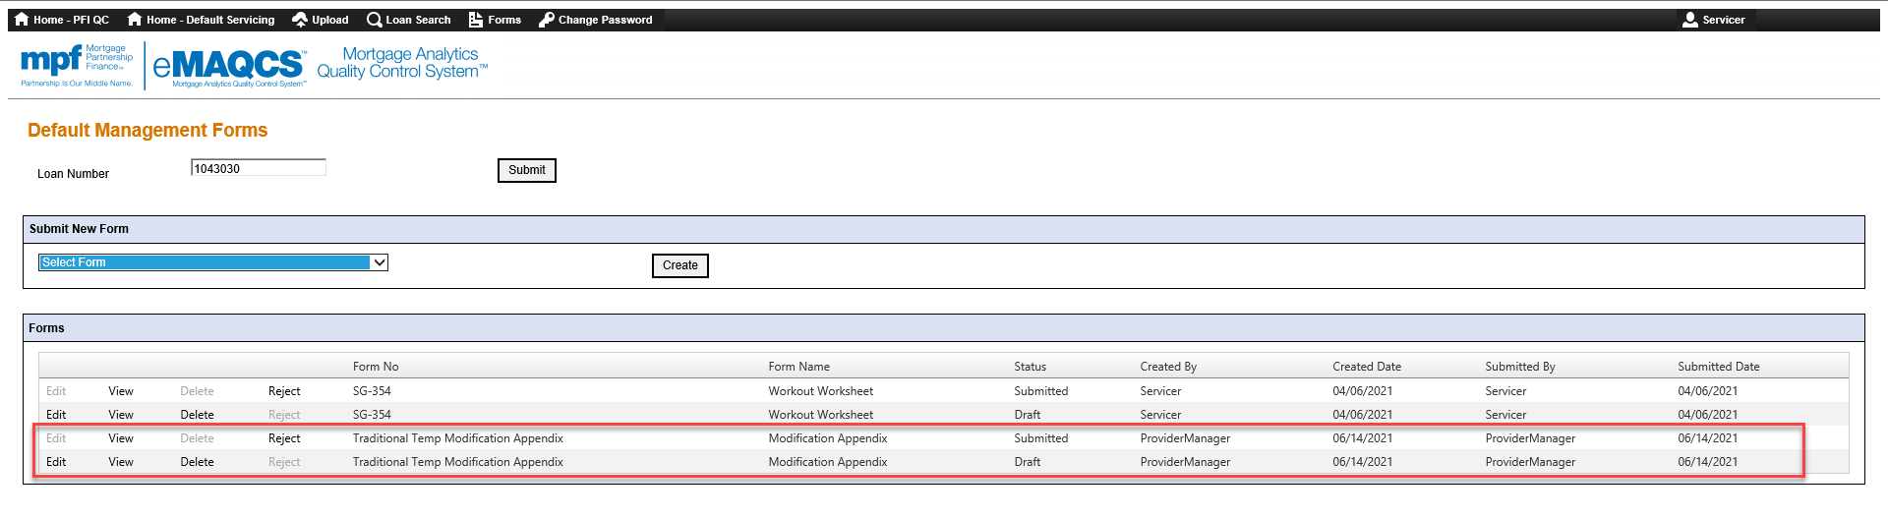

**Step 8** – Once the **Traditional Temporary Loan Payment Modification Appendix** form has been submitted successfully, you will receive an email confirming that the Traditional Appendix has been received and will be assigned to an analyst for review.

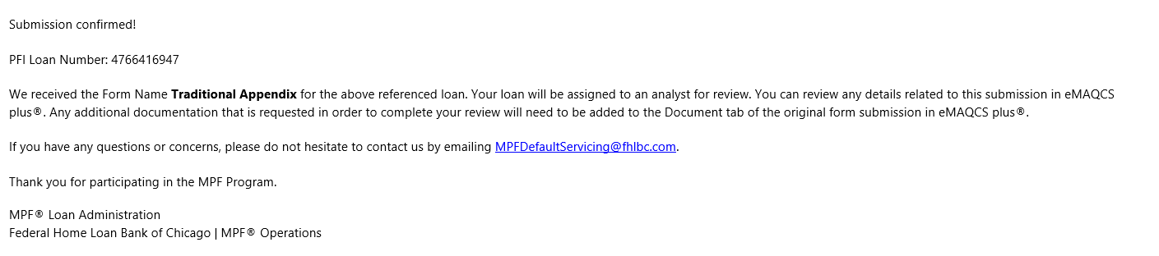

**Step 9** – Once the **Traditional Temporary Loan Payment Modification Appendix** form has been assigned to an analyst, you will receive an email confirming that the Traditional Appendix has been assigned to an analyst for review. You can review any details related to this submission in eMAQCS plus®. Any additional documentation that is requested in order to complete your review will need to be added to the Document tab of the original form submission in eMAQCS plus®.

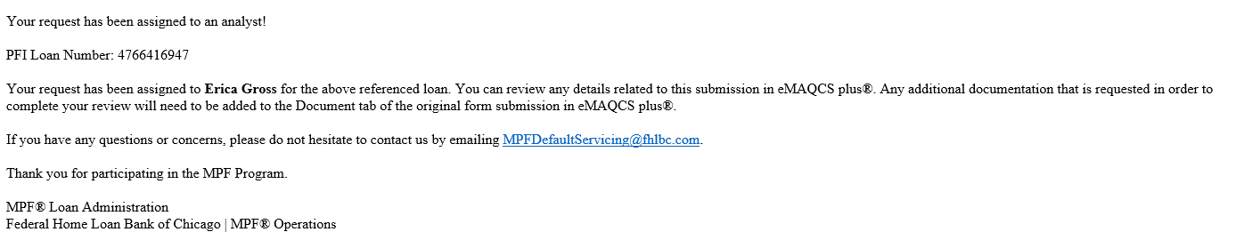

**Step 10** – Once the **Traditional Temporary Loan Payment Modification Appendix** form has been approved (if applicable), you will receive an email specifying the approved terms with additional instructions to return a copy of the executed SG400 & SG401 agreements to the MPF Provider within 90 days along with confirmation from your office that the borrower successfully made all 3 trial payment plans successfully.

